Use Case Specification

DMT/RM01/TMP

|  |  |
| --- | --- |
| Project Code | PRJ_HOTELMANAGEMENT_01 |
| Project Name | Hotel Management |

|  |  |  |
| --- | --- | --- |
| Prepared/Modified by | Role | Date of Preparation |
| Harshita Ahuja | Test Engineer | 22/10/2018 |
| Reviewed by | Role | Date of Review |
| Himanshu,Ijas,Kartik | SME |  |
| Approved by | Role | Date of Approval |
| Christy | Test Manager |  |
| Circulation List |  | Version Number of the template: |
| Version Number | 1 |  |

<<Customer>> REVIEW HISTORY

<<Customer comments on the Use case along with the signed off is tracked here>>

|  |  |  |  |  |  |  |
| --- | --- | --- | --- | --- | --- | --- |
| Version | <<Version number>> |  |  |  |  |  |
| Date | <<Date of Review>> |  |  |  |  |  |
| Reviewed by | << Reviewer Name>> |  |  |  |  |  |
| Reviewed UI Specification doc | << Whether UI Specification doc is reviewed >> |  |  |  |  |  |
| All Open Queries/issues closed | << Whether all the open queries and issues resolved>> |  |  |  |  |  |
| Agreement on Assumptions | <<Whether all the assumptions have been agreed upon by the customer>> |  |  |  |  |  |
| Sign Off | <<Signature>> |  |  |  |  |  |

Disclaimer:

The scope of the project ‘<<Project Name>>’ is restricted to the contents of this signed off use case.

**TABLE OF CONTENTS**

1. Use case Name 4
2. Actor(s) 4
3. Preconditions 4
4. Flow of events 4
   1. Basic Flow 4
   2. Alternate Flow 1 5
5. Exception Flow
   1. Exception Flow 1 5
   2. Exception Flow 2 6
   3. Exception Flow 3 6
   4. Exception Flow 4 7
   5. Exception Flow 5 7
   6. Exception Flow 6 7
6. Post Conditions 8
7. Special Requirements
   1. Performance 8
   2. Availability 8
   3. Business Rules 9
8. Diagrams
   1. Use Case Diagram
      1. For Successful Registration 10
9. Scenarios
   1. Success Scenarios 11
   2. Failure Scenarios 11
10. Issues 11
11. UI Specifications 12
12. Assumptions 12
13. Revision History of the work product 13

Use Case Name: online banking system

**Use Case ID:** HotelManagement_01

**Brief Description:** This usecase describes about the hotel booking system.

Actor(s)

1. Admin
2. Hotel Management System

Preconditions.

1. The employee has successfully login in to the the site https:\\ <http://ndafile:8081/Spring_Hotel/login.html>
2. The user must be the registered user if he/she is not a registered one than he/she has to login.

Flow of Events

4.1 Basic Flow

**Name:** Successful Registration

1. Login into the <http://ndafile:8081/Spring_Hotel/login.html>
2. User enters Name
3. User enters UserID
4. User enters Mobile no.
5. User enters Phone.
6. User enters Address.
7. User enters Email.
8. User enters Password.
9. User enters Retype Password.
10. User clicks on Submit.
11. After clicking on the button, message will get displayed “Request submitted”.
    1. Alternative Flows

Alternate Flow 1: Successful registration

1. Login into the <http://ndafile:8081/Spring_Hotel/login.html>
2. User enters Name
3. User enters UserID
4. User enters Mobile no.
5. User enters Address.
6. User enters Email.
7. User enters Password.
8. User enters Retype Password.
9. User clicks on Submit.
10. After clicking on the button, message will get displayed “Request submitted”.

EXCEPTION FLOW

Exception Flow 1: unsuccessful registrtaion due to userid

1. Login into the <http://ndafile:8081/Spring_Hotel/login.html>
2. User enters Name
3. User enters invalid UserID
4. User enters Mobile no.
5. User enters Phone.
6. User enters Address.
7. User enters Email.
8. User enters Password.
9. User enters Retype Password.
10. User clicks on Submit.
11. After clicking on the button, error message will get displayed “UserID is allocated to someone else”.

Exception Flow 2 :unsuccessful registration due to mobile number.

1. Login into the <http://ndafile:8081/Spring_Hotel/login.html>
2. User enters Name
3. User enters UserID
4. User enters invalid Mobile no.
5. User enters Phone.
6. User enters Address.
7. User enters Email.
8. User enters Password.
9. User enters Retype Password.
10. User clicks on Submit.
11. After clicking on the button, error message will get displayed that “Please enter 10 digit mobile number”.

Exception Flow 3 :unsuccessful registration due to Retype password.

1. Login into the <http://ndafile:8081/Spring_Hotel/login.html>
2. User enters Name
3. User enters UserID
4. User enters Mobile no.
5. User enters Phone.
6. User enters Address.
7. User enters Email.
8. User enters Password.
9. User enters invalid Retype Password.
10. User clicks on Submit.
11. After clicking on the button, message will get displayed “Password doesn’t match”.

Exception Flow 4: Web Server Down

1. Login into the <http://ndafile:8081/Spring_Hotel/login.html>
2. User enters Name
3. User enters UserID
4. User enters Mobile no.
5. User enters Phone.
6. User enters Address.
7. The system displays an error message regarding web server unavailability problem

Exception Flow 5: Database Connectivity Error

1. Login into the <http://ndafile:8081/Spring_Hotel/login.html>
2. User enters Name
3. User enters UserID
4. User enters Mobile no.
5. User enters Phone.
6. User enters Address.
7. The system displays an error message regarding database connectivity problem.

Exception Flow 6: Network Connectivity Error

1. Login into the <http://ndafile:8081/Spring_Hotel/login.html>
2. User enters Name
3. User enters UserID
4. User enters Mobile no.
5. User enters Phone.
6. User enters Address.
7. The system displays an error message regarding network connectivity problem.

Post Conditions

| Flow Name | Post Condition |
| --- | --- |
| Successful Registration | System displays the message “Request Submitted” with cab request id |
| Unsuccessful Registration due to UserID | System displays the error message “Request Not Submitted” with UserID is allocated to someone else |
| Unsuccessful Registration due to Mobile No. | System displays the error message “Request Not Submitted” with Please enter 10 digit mobile number |
| Web Server Down | The system should display an error message to the user regarding web server unavailability problem |
| Database Connectivity Error | The system should display an error message to the user regarding the database connectivity problem |
| Network Connectivity Error | The system should display an error message to the user regarding the network connectivity problem |

Special Requirements

Performance

The applicant should receive the mail having the details of registration.

Availability

* + 1. Application is up and running 24*7.

Business Rules

| Business Rule Name | Business Rule Description | System action (if BR fails) |
| --- | --- | --- |
| BR01 | Mobile Number must be 10 digit. | Error message is displayed if 10 digit mobile no. is not entered. |
| BR02 | User ID- must be the combination of numbers and characters. | Error message is displayed criteria is not matched. |
| BR03 | Email- must have specific domain name. | Error message will get displayed if domain name doesn’t exists. |
| BR04 | Password must be the combination of characters, numbers, and atleast 1 special character and length must be minimum 8 characters. | Error if wrong is enabled. |

Diagrams

Use Case Diagram

* 1. For Successful registration

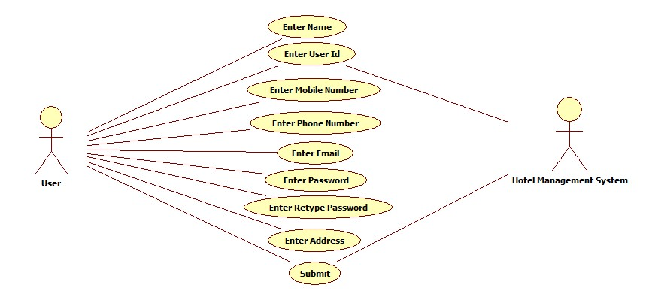

Scenarios

Success Scenarios

* Successful submission of user details.

Failure Scenarios

* Failed submission of registration due to invalid UserID.
* Failed submission of registration due to invalid Mobile No.
* Failed submission of registration due to web server down.
* Failed submission of registration due to database connectivity.
* Failed submission of registration due to network connectivity.

Issues

1. What is to be done if web server is down?
2. What is to be done if there is data connectivity error?

UI SPECIFICATIONS

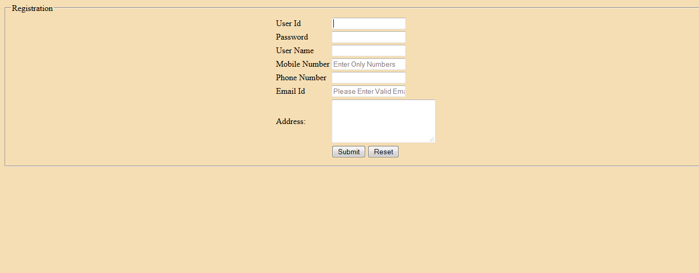

Assumptions

1.Only company employees, registered user and admin avail this service.

REVISION HISTORY OF THE WORK PRODUCT

<to be maintained by projects>

|  |  |  |  |  |  |
| --- | --- | --- | --- | --- | --- |
| # | Date | Version # | Section Changed | Details of changes made | Approved By |
| 1 |  |  |  |  |  |
| 2 |  |  |  |  |  |